Experiment 11: Online Supermarket Using Cloud Computing
Aim
To create a simple cloud-based software application using Zoho Creator for an online supermarket to manage customer information, product details, quantities, and item classifications, demonstrating SaaS.
Algorithm
- Open Zoho Creator and sign in.
- Create a new application named Online Supermarket.
- Create a form named Customer Information.
- Add fields for customer name, address, phone, and email.
- Create a form named Item Details.
- Add fields for item name, quantity, price, and item classification.
- Add suitable categories such as groceries, fruits, vegetables, and beverages.
- Save the application and enter customer and item details.
- View the stored records and verify the application.

Implementation
Input
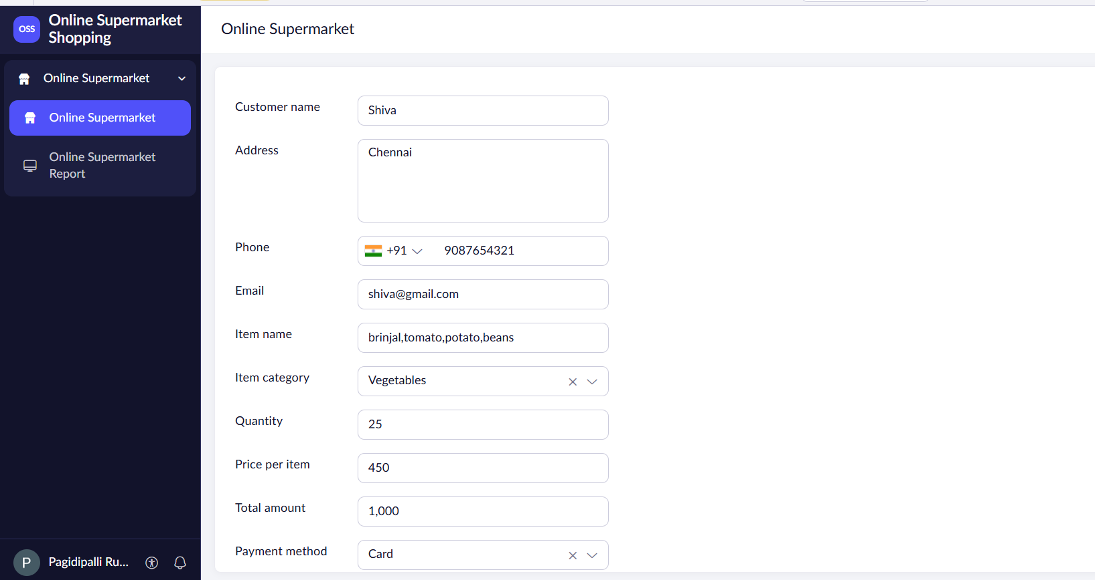

Output
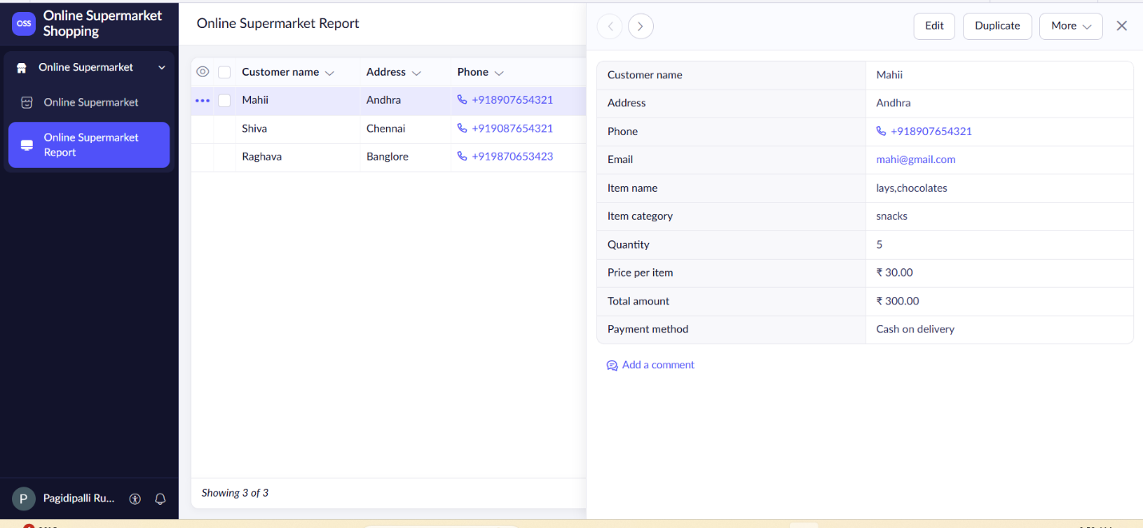

Result
Thus, a cloud-based Online Supermarket application was created successfully using Zoho Creator to manage customer details, products, quantities, and item classifications, demonstrating SaaS.

